MACH4METAL

metalworking machinery
Transito 21
6909 DA BABBERICH Netherlands
Tel. +31 (0)316-247123
Fax: +31 (0)316-247956
info@mach4metal.com
www.mach4metal.com

Bank No : 66.52.13.883
IBAN : NL33 INGB 0665 2138 83
BIC : INGBNL2A

Notching machine BOSCHERT

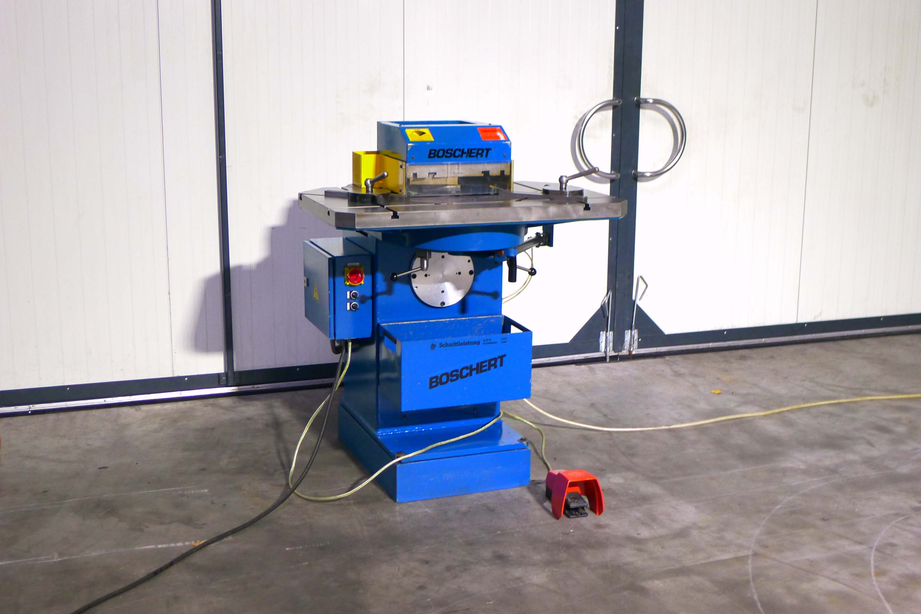
- Make : BOSCHERT GmbH
- Typ : Mini S
- Mach.No. : 356
- Age : 1991

- Blade length 225
- Capacity 400 N/mm : 4
- Capacity 700 N/mm : 3

- Cutting angle :30 – 120 Grad
- Cutting length : 150 x 150
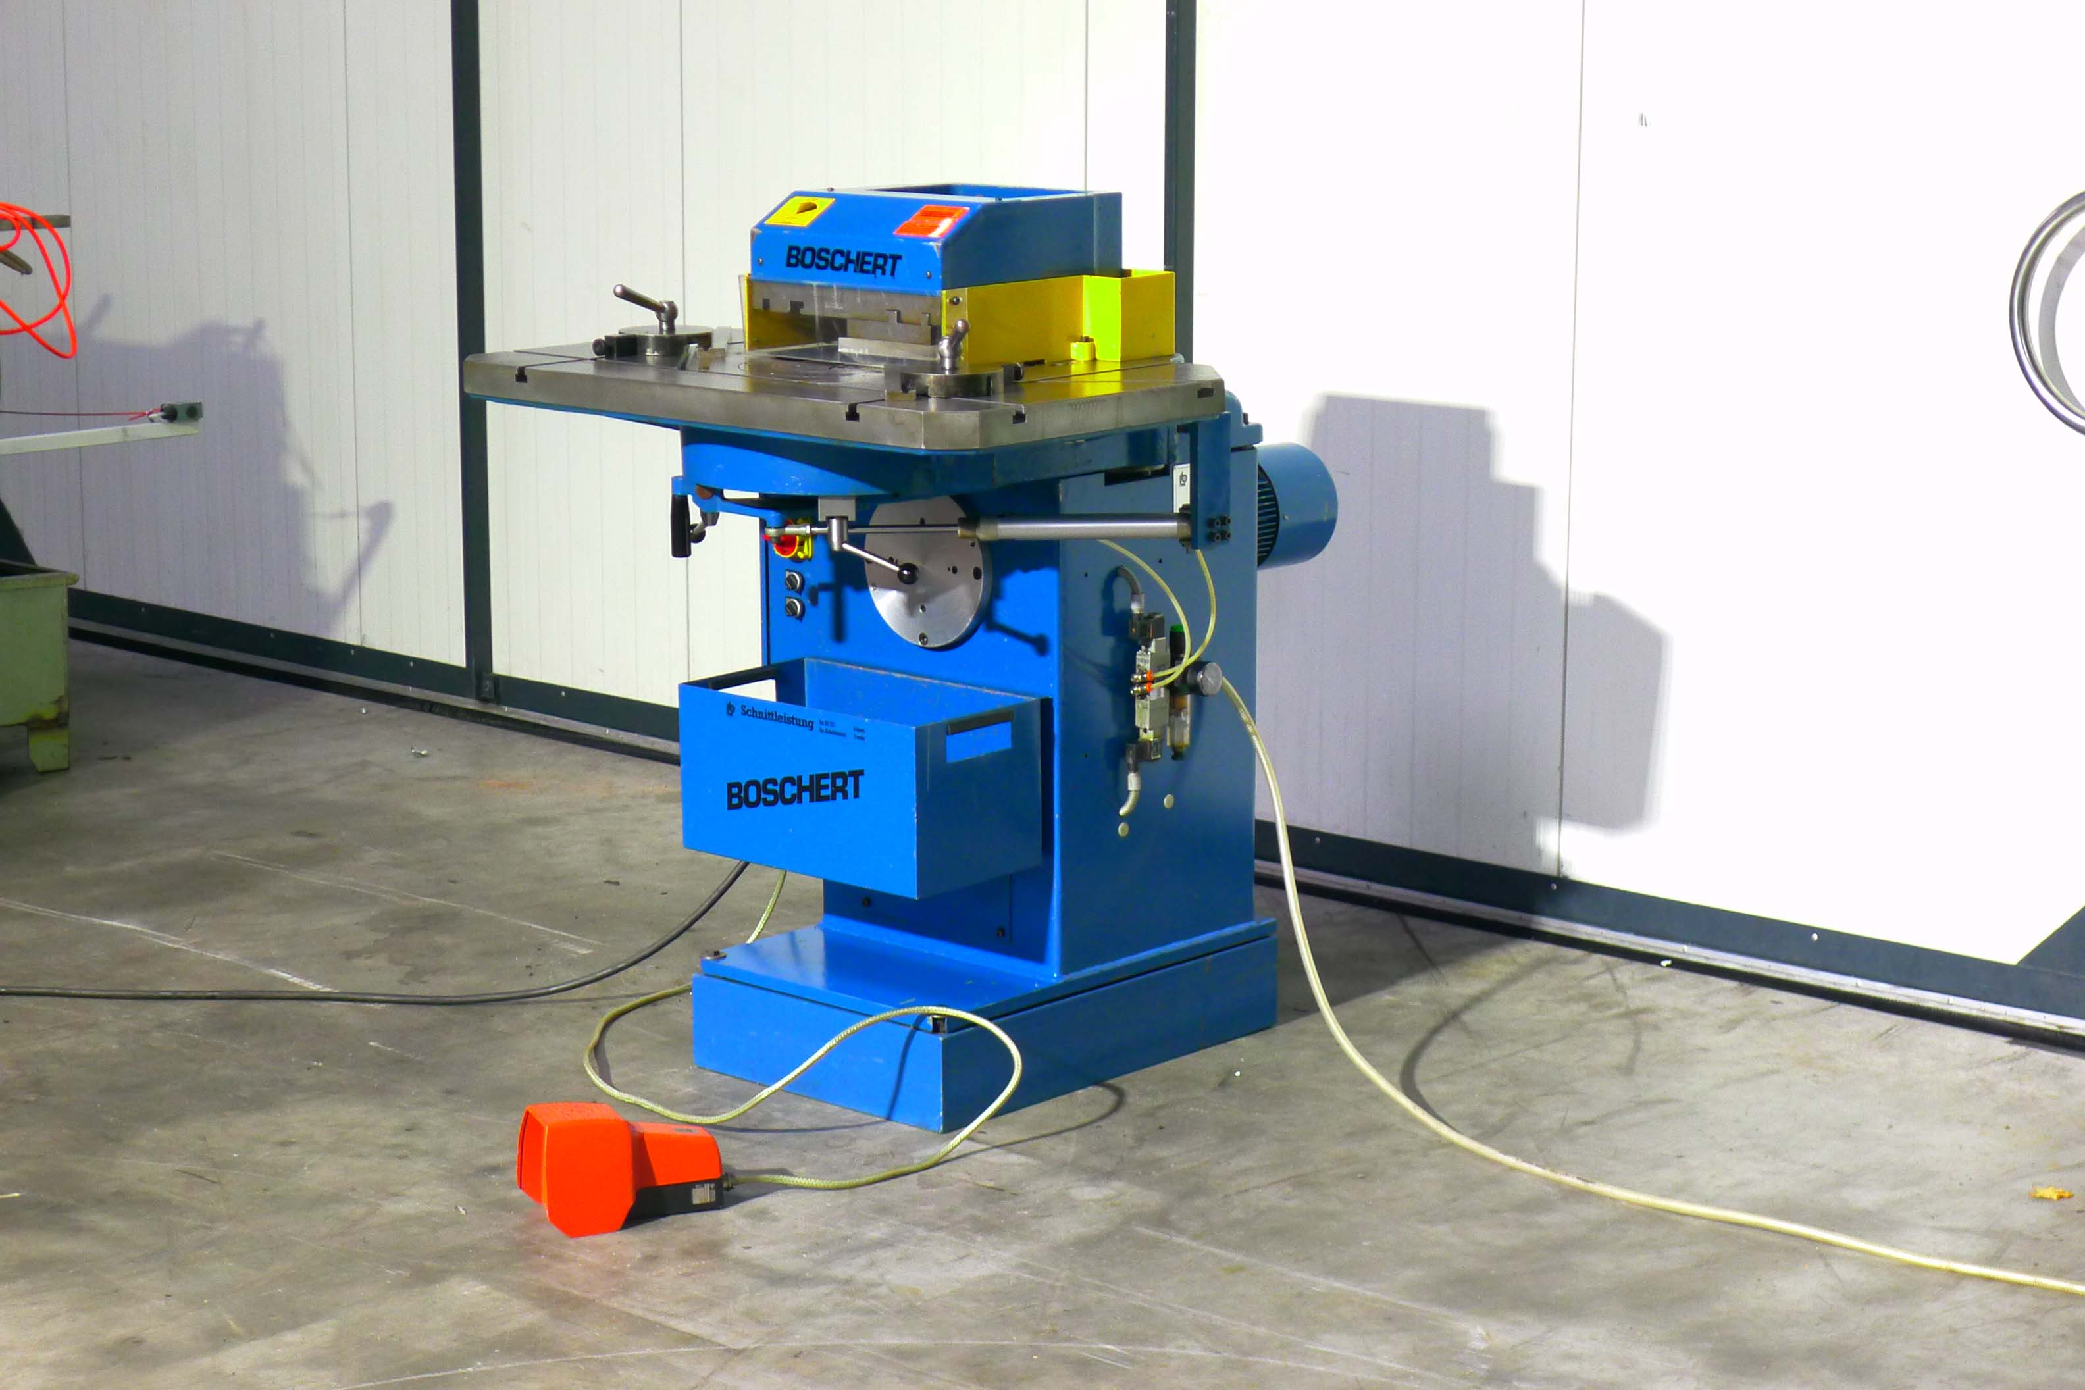
- Hub : 60 L/Min

- Table length : 1.000
- Table width : 650

- Dimensions
- Length : 1.300
- Width : 1.500
- Height : 1.300
- Weight : 900
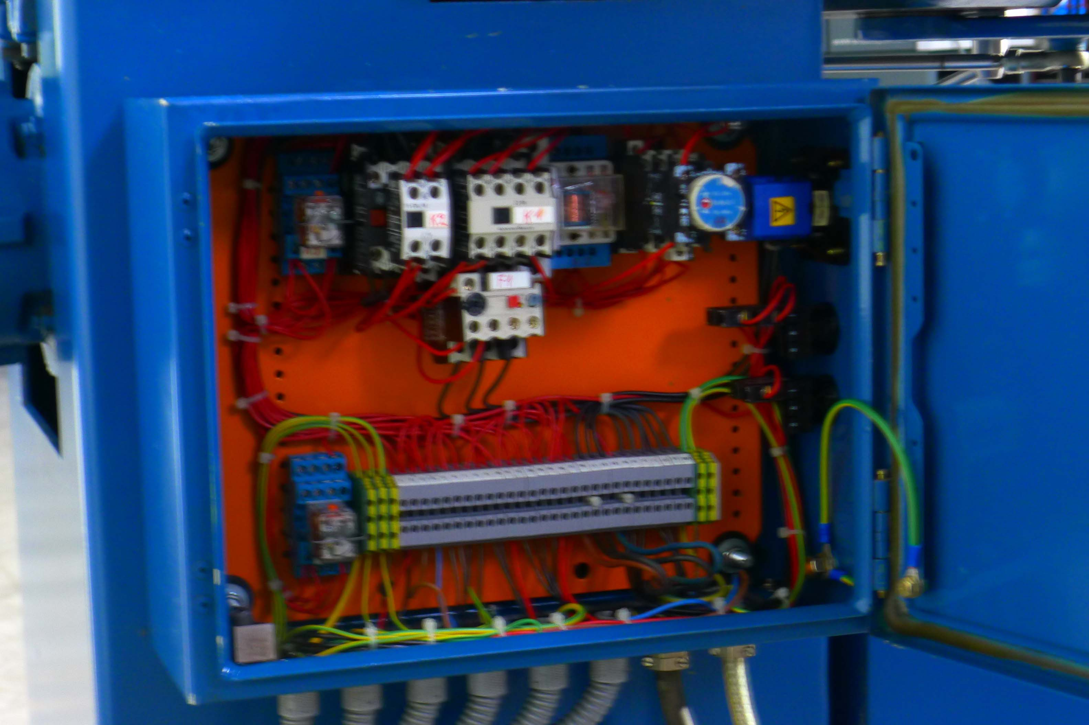

- Power 4.5 kVa
- Incl. set angle stops
- Incl. table tool

- Good working condition
- Under power
- Fully hydraulic

Please Note: The above information has been obtained to the best of our ability and belief from, and from the manufacturers where possible. It is given in good faith, but its accuracy can not be guaranteed. Accordingly, it will not form a representation or constitute contractual terms. We advise you to check any vital details!

